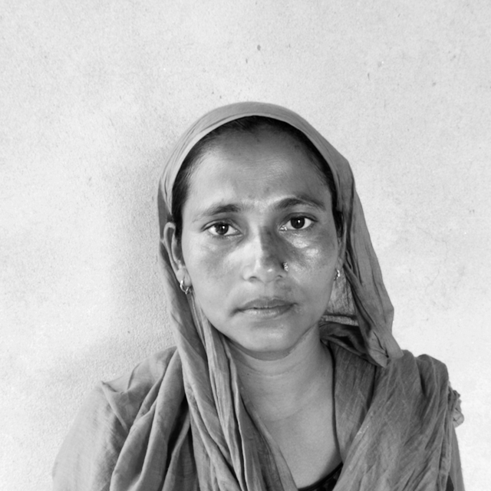
Hello, my name is Asmina Khatun and I am 32 years old from Goghanpur.
Growing up wasn’t easy for me as at a very young age both my mother and my father died. This left my older brothers and sisters in charge of their seven siblings. There was only little time to play and certainly no time for school. At the age of 8 or 9, I had to go and work on a farm, I would work long hours with no pay but in exchange for food.
In rural Nepal, finding a husband is a big part of every girl’s life. However, finding one for me was extremely difficult because of my family situation. No men would accept me, not only was I poor but also people would say “if I didn’t grow up with a mother and father how would I have learned to look after and raise a family of my own.”
In Terai region, marriage is not only very important, but without which life would be impossible. With marriage not only comes the responsibility of my husband but also my husband’s family. At the age of 18, I had an arranged marriage. A big part of wedding culture is having a celebration where everyone from the village gets invited. These costs are the responsibility of the bride and is lots of money to bear. This put me under a lot of stress as there was a lot of social pressure to spend money which I didn’t have. I had to borrow the money from my friends, without this celebration I would have appeared to have been an even more unsuitable wife and my soon to be husband would not have accepted me.
My husband is also poor and had lost his parents, he works on a farm and it was only because he was in a similar situation as me that he agreed to accept me as his wife. He can be verbally abusive and controlling and this makes me feel alone and miss my mother and father even more as they would have never allowed me to marry such a man.
I have three children now, one daughter and two sons and it had been a constant financial struggle to be able to provide for them. With my husband not having a good income and myself not being able to get a job life was getting hard and I was worried that I was not going to be to be a good mother that I had always wanted to be.
It was then, when the flood hit that I met Saheen and she told me about the LWH workshop. As soon as I heard about it, I applied as soon as I could and started receiving the training to learn new skills. This was the first paid job I ever had and being able to make an income of my own made me so happy. Now, I feel like I can help my husband to support my family and give my children good opportunities in life.
With the help of LWH, more workshops are being built and more training is being offered. Many more women are being given the opportunities that I have and are now able to make some money and provide basic necessities for their families.
While everything is getting more expensive, this additional source of income becomes more and more vital to families. It is also important to know that my daughter can, if she wishes, look up to LWH to help improve her prospects.

